# VISVESVARAYA TECHNOLOGICAL UNIVERSITY

**“Jnana Sangama”, Belagavi-590 018, Karnataka**

**Project Report on**

“HOSPITAL MANAGEMENT”

**Submitted in partial fulfillment of the requirements for the award of the degree of Bachelor of Engineering**

**in**

**Computer Science & Engineering**

**Submitted by**

**USN Name**

**1BI20CS011 Aditya Kulkarni**

**1BI20CS030 Anurag Kumar**

**1BI20CS060 Divyansh Nama**

**1BI20CS065 Gaurav Saraiwala**

**1BI20CS077 Himank Mishra**

**1BI20CS117 Nishit Khamesra**

**1BI20CS153 Satyam Kumar**

Under the Guidance of

**Divyashree P**

Assistant Professor Department of CS&E, BIT Bengaluru-560004



**DEPARTMENT OF COMPUTER SCIENCE & ENGINEERING**

# BANGALORE INSTITUTE OF TECHNOLOGY

K.R. Road, V.V. Pura, Bengaluru-560 004

## 2020-21

**VISVESVARAYA TECHNOLOGICAL UNIVERSITY**

**“Jnana Sangama”,** Belagavi-590 018, Karnataka

## BANGALORE INSTITUTE OF TECHNOLOGY

Bengaluru-560 004



**DEPARTMENT OF COMPUTER SCIENCE & ENGINEERING**

***Certificate***

This is to certify that the implementation of **DATA STRUCTURES AND APPLICATION MINI PROJECT** **(18CS32)** entitled “**HOSPITAL MANAGEMENT SYSTEM**” has been successfully completed by

**Name USN**

**Aditya Kulkarni 1BI20CS011**

**Anurag Kumar 1BI20CS030**

**Divyansh Nama 1BI20CS060**

**Gaurav Saraiwala 1BI20CS065**

**Himank Mishra 1BI20CS077**

**Nishit Khamesra 1BI20CS117**

**Satyam Kumar 1BI20CS** **153**

of III semester B.E. for the partial fulfillment of the requirements for the Bachelor's degree in Computer Science & Engineering of the Visvesvaraya Technological University during the academic year 2020-2021.

**Divyashree P**

Assistant Professor

Department of CSE, BIT

|  |  |  |
| --- | --- | --- |
|  |  |  |
|  |  |  |

**Abstract**

* The HOSPITAL MANAGEMENT is a simple project which is designed in **C language**.
* The coding of this project is done in such a way that the user feels enthralling and blessed to have come to our hospital with such good Faculties and Doctors with so user friendly Paperwork.
* This project is coded in such a way that it's very **user-friendly**. This project is developed in the IDE called as **Visual Studio Code** with the help of **GCC compiler**.
* When you run the application will be asked to enter certain details of patient.

**Acknowledgement**

We take this opportunity to acknowledge all the people who have helped us wholeheartedly in every stage of this project. We would like to express our sincere gratitude to Mrs. Divyashree P and our honorable principal Dr Aswath M.U. of Bangalore Institute of Technology for their valuable guidance and support in completing our project in Data Structure and Application on **HOSPITAL MANGEMENT SYSTEM.**

Your valuable guidance and suggestions helped us in various phases of the completion of this project.

Finally, as a team, we would also like to appreciate each one of us for their support and coordination in the completion of this project. We hope we will achieve more in our future endeavors.

**Index**

**Chapter 1: Introduction**

**Chapter 2: Problem Statement and Objective**

**Chapter 3: System Requirements**

**Chapter 4: Flowchart with explanation**

**Chapter 5: Design**

**Chapter 6: Implementation**

**Chapter 7: Testing and Results**

**Chapter 8: Applications**

**Chapter 9: Conclusion and Future work**

**Chapter 10: References**

**CHAPTER-1**

**INTRODUCTION**

**1. 1 About Hospital Management System:**

Hospital management system is a computer system that helps manage the information related to health care and aids in the job completion of health care providers effectively. They manage the data related to all departments of healthcare such as,

* Financial
* Inpatient
* Outpatient
* Materials
* Nursing
* Pharmaceutical
* Neurology
* Cardiology etc.

HMS came into the picture of hospital management as early as 1960 and have ever since been evolving and synchronizing with the technologies while modernizing healthcare facilities. In today’s world, the management of healthcare starts from the hands of the patients through their mobile phones and facilitates the needs of the patient.

**CHAPTER-2**

**PROBLEM STATEMENT AND OBJECTIVE**

**2.1 Problem Statement:**

This project is aimed to automate the hospital management system. The

purpose of the project entitled as HOSPITAL MANAGEMENT SYSTEM is to

computerize the Front Office Management of Hospital to develop software which is user friendly, simple, fast, and cost – effective.

It deals with the collection of patients information, diagnosis details, etc. Traditionally, it was done manually.

The main function of the system is to register and store patient details and doctor details and retrieve these details as and when required, and also to manipulate these details meaningfully.

This function of Hospital Management Information System deals with

registering the new Patient by giving unique Identification Number to the Patient. This number is unique throughout the System for identifying the patient. Simultaneous update and changes are made to the databases. Identification number is also provided to doctor to retrieve and to change doctor details.

The software is used by administrator or receptionist in the hospital. The software is secured by username and password, accessed by administrator or receptionist of the hospital.

**2.2 Objectives:**

Design a system for better patient care.

Reduce hospital operating costs.

Provide MIS ([Management Information System](http://www.datamateuae.com/)) report on demand to management for better decision making.

Better co-ordination among the different departments.

Provide top management a single point of control.

**CHAPTER-3**

**SYSTEM REQUIREMENTS**

**3.1 System requirements:**

**3.1.1 The minimum requirements are: -**

3.1.1.1 Intel Core i5 or i7 processor

3.1.1.2 Full HD resolution, ideally 1920×1080

3.1.1.3 8GB of RAM

**3.1.2 IDE used: -**

VS CODE

Visual Studio Code is a code editor made by Microsoft for Windows, Linux and macOS. Features include support for debugging, syntax highlighting, intelligent code completion, snippets, code refactoring, and embedded Git.

Also, we used Fedora IDE.

**3.1.3 Compiler used**: -

MinGW is a compiler system based on the GNU GCC and Binutils projects that compiles and links code to be run on Win32 (Windows) systems. It provides C, C++ and Fortran compilers plus other related tools. 'MinGW' refers to the "Minimalist GNU for Windows" project.

**CHAPTER-4**

**FLOWCHART WITH EXPLANATION**

**4.1 Flow chart:**

Adding new data Patient-id,age,blood group,name,department,admission date, release date,investigating doc,disease,guardian,emergency contact no,fees,phone no

i 0

F

Delete the required node out of linked list

Display key not found

Read the new data

F

T

Is key==cur->info

Read data and insert data into linked list

Edit or upgrade the information

Display patient details by- ascending order of names,department wise,age group wise,blood group wise

Search patient by name,department,date of admission and date of release

F

T

Patient doesn’t exist

Check patient department

And age and generate bill accordingly by providing discounts

F

T

Is patient_ID=

unique_ID

Generation of bill

Node not found

Delete the node

Is cur->patient_id==unique_ID

**CHAPTER-6**

**IMPLEMENTATION**

**6.1 Defining a Linked List**

We define a Linked List by mentioning the parameters it’s going to hold, i.e., all different fields of information.

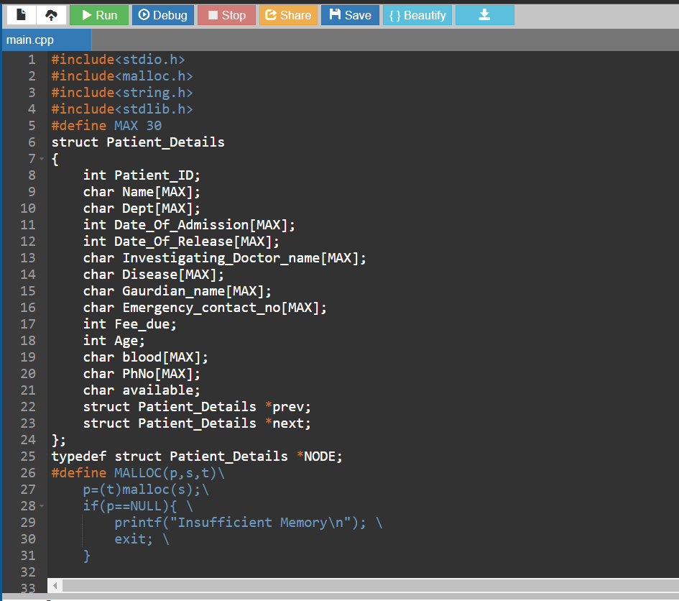

**6.2 Searching of Patients Information**

We have provided search option by various parameters to search making it convenient for both the medical staff and an individual user.

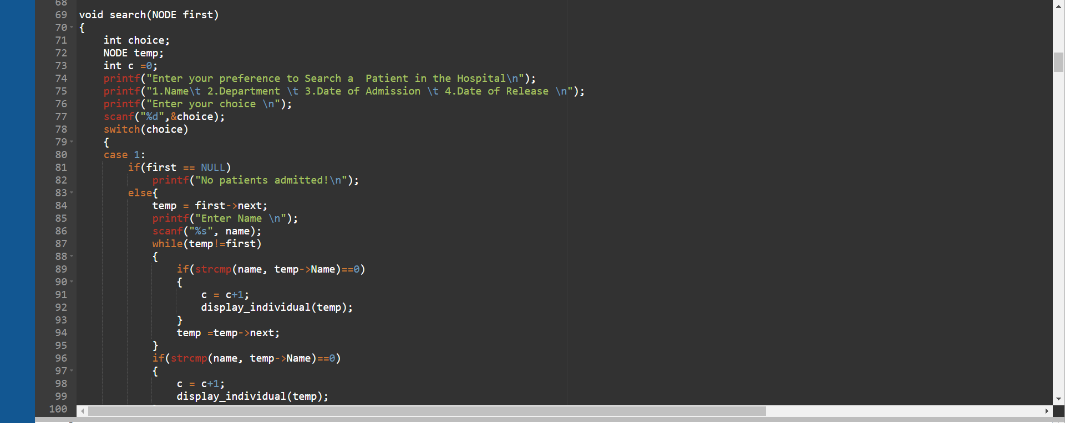

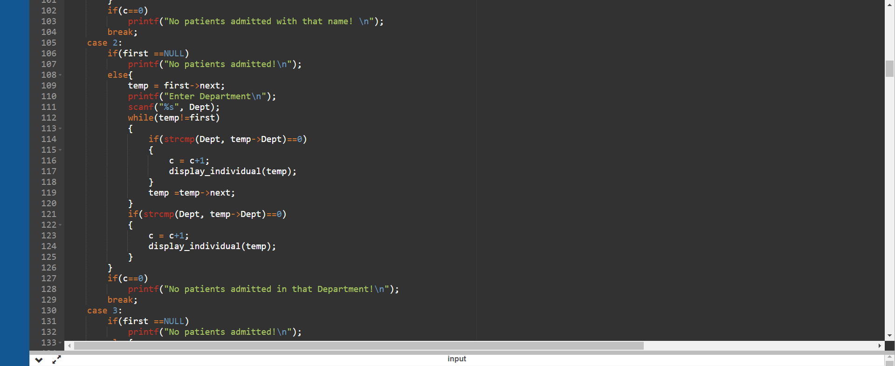

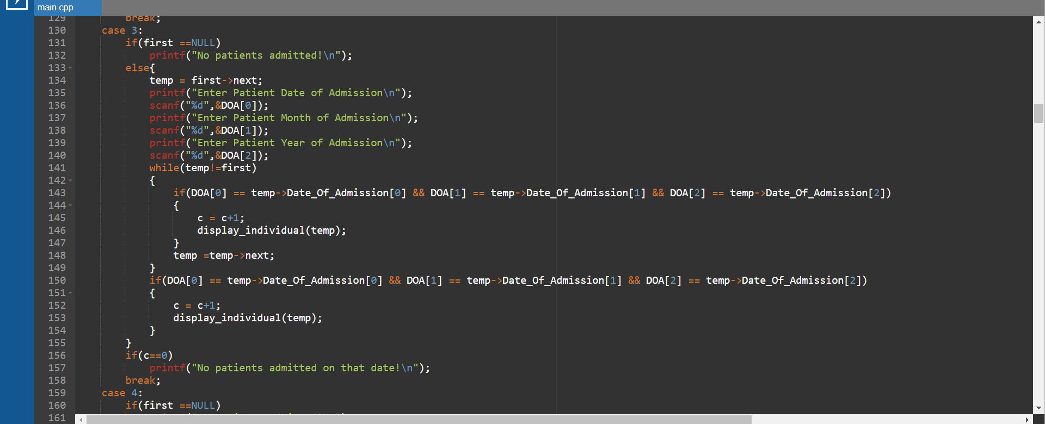

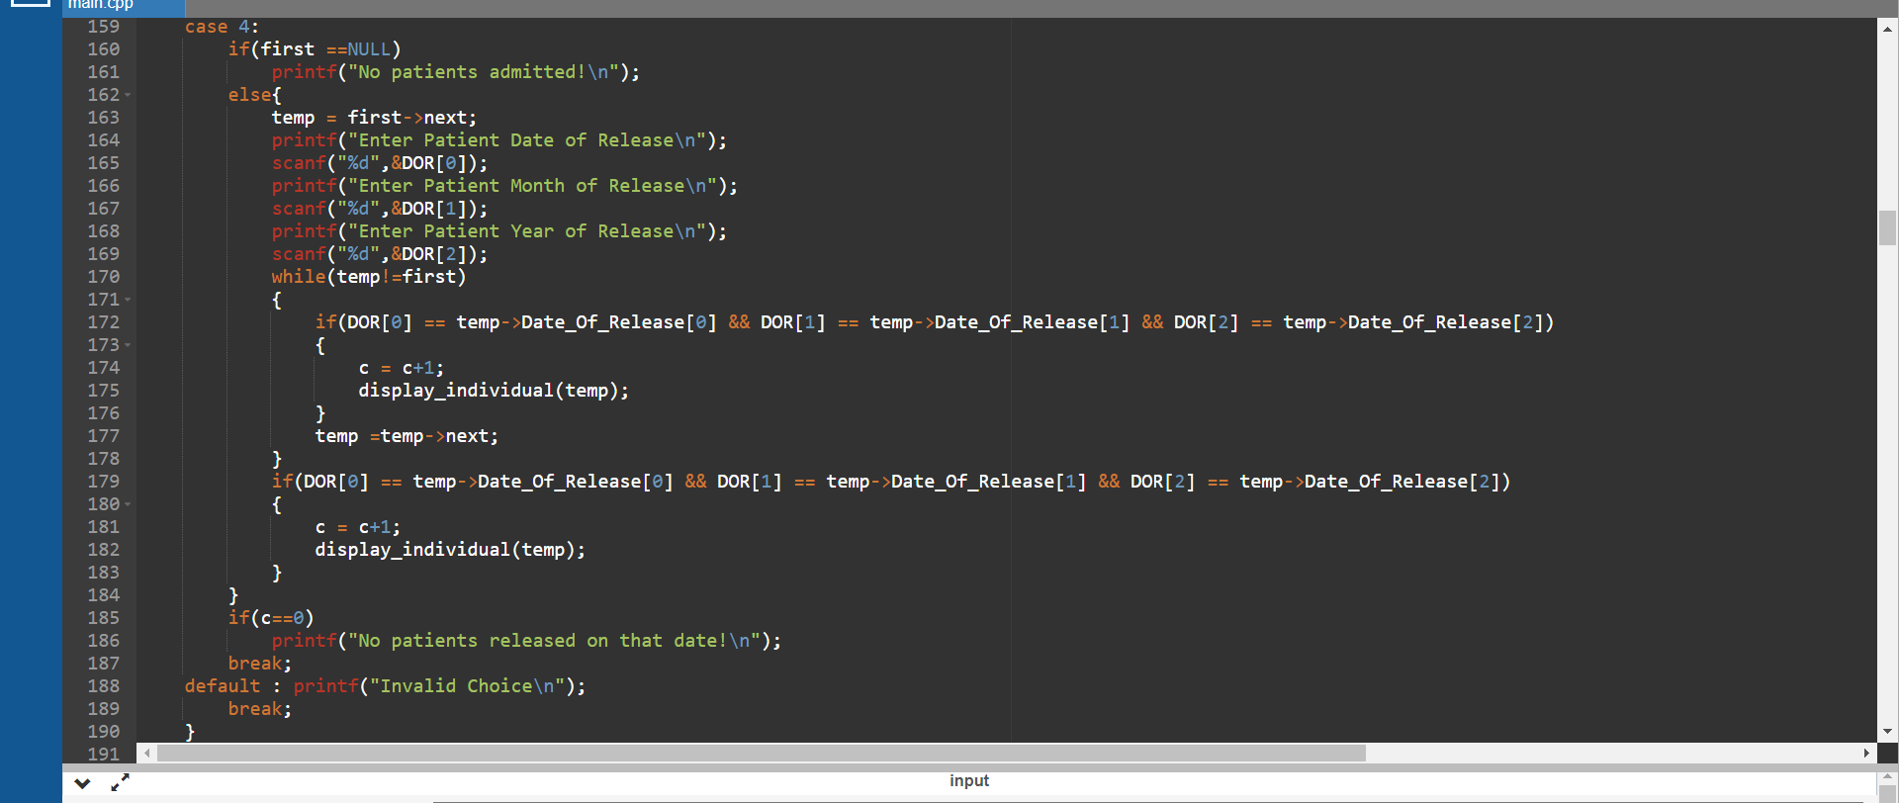

**6.3 Bill Generation:**

Bill Generation uses nested if -else -if Statements.

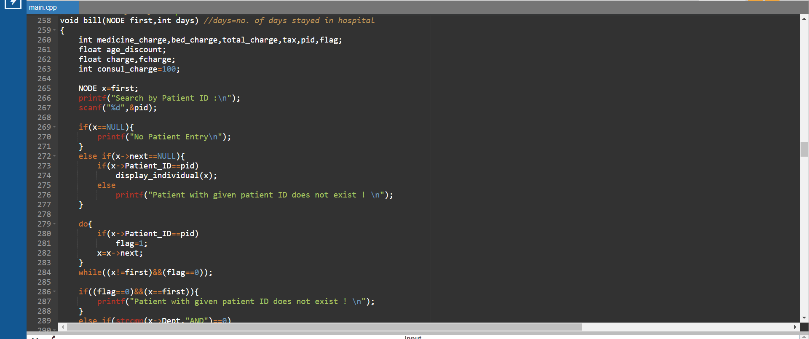

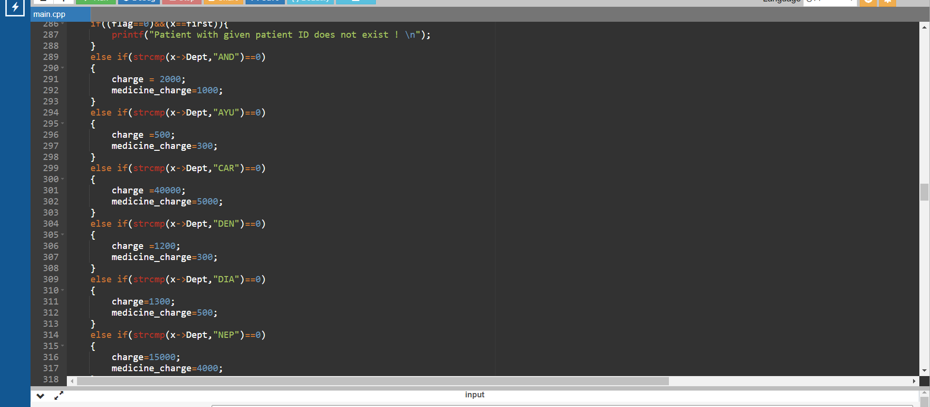

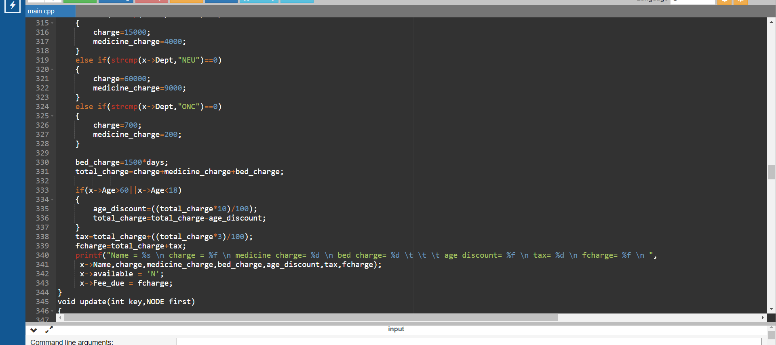

**6.4 Editing any information:**

We Have used many ways to edit any particular field of information by using Switch Cases.

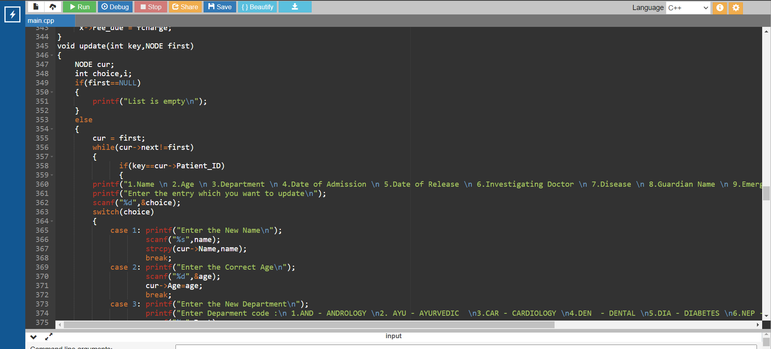

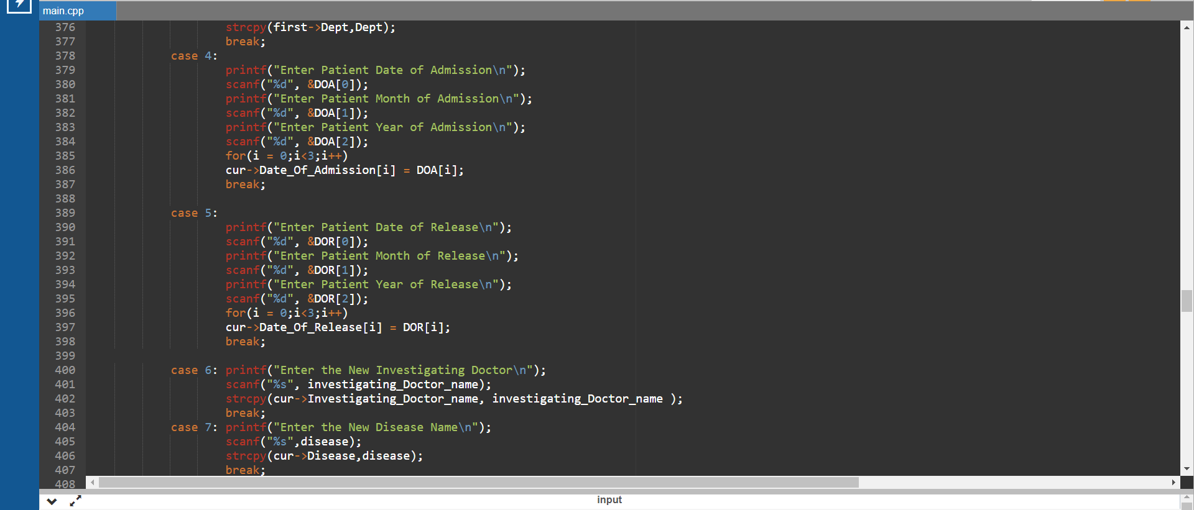

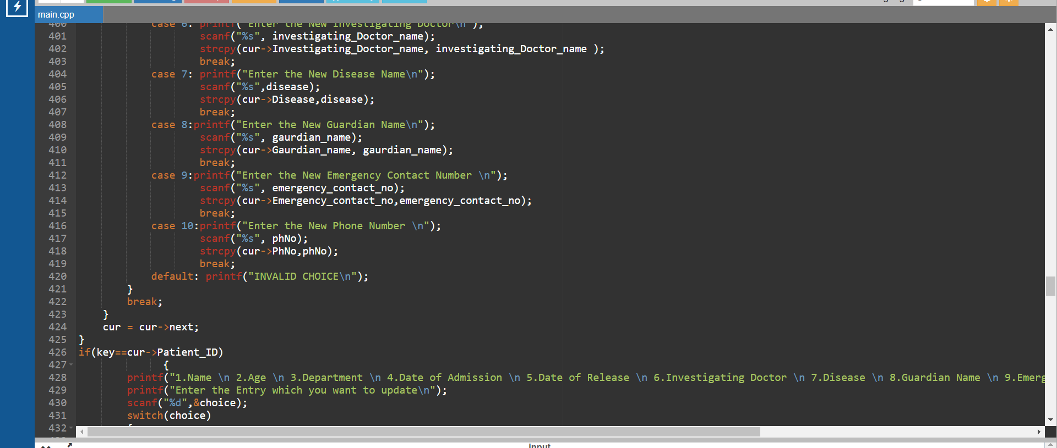

**CHAPTER-7**

**TESTING AND RESULTS**

**7.1 Testing:**

Here we have provided pictures of code running in actual time.

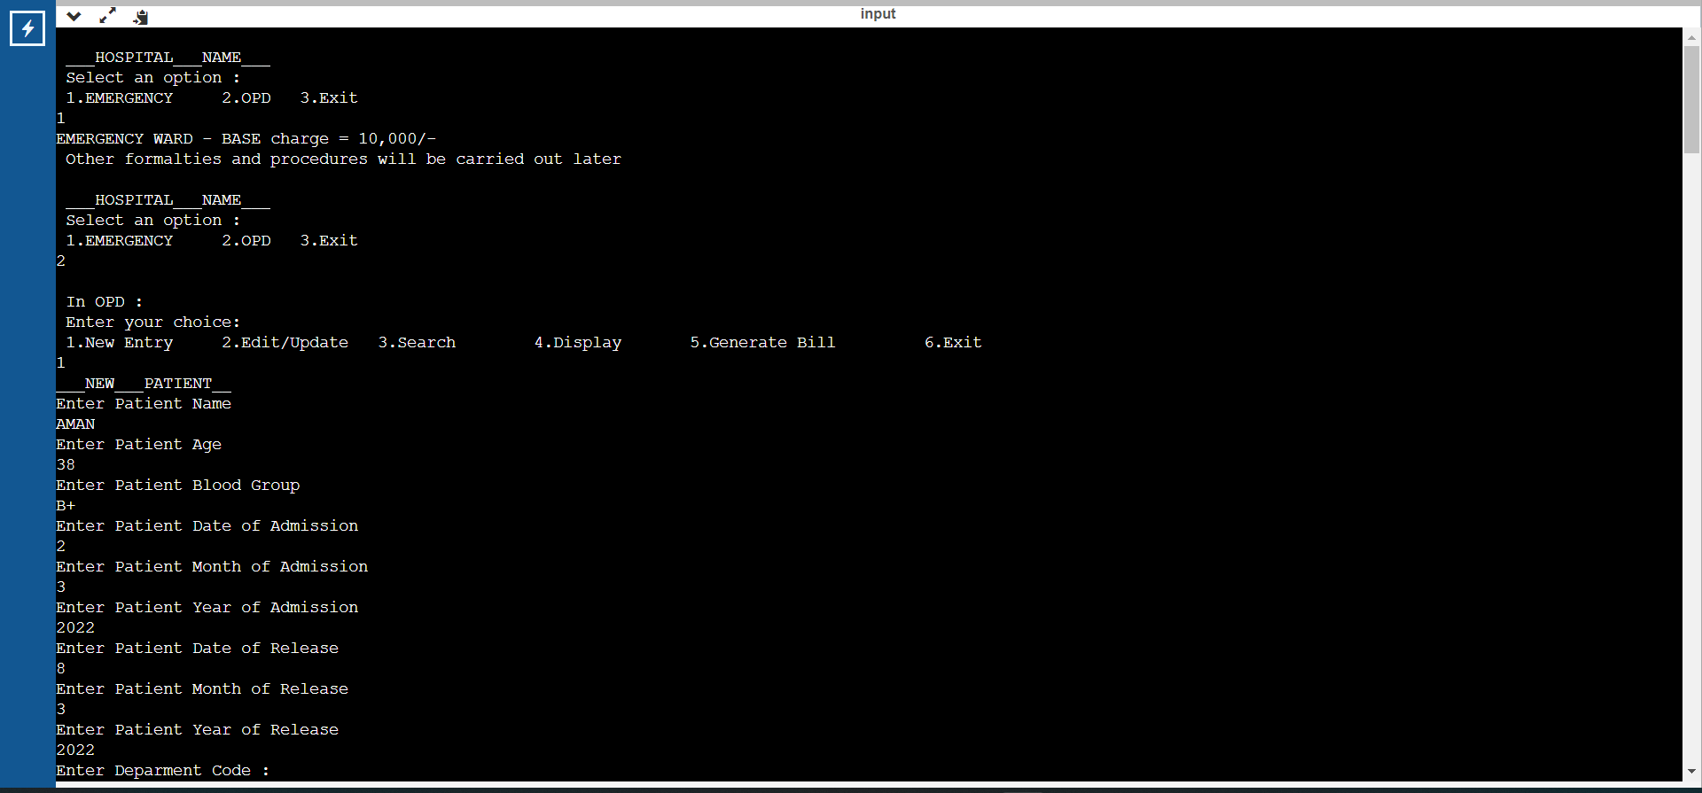

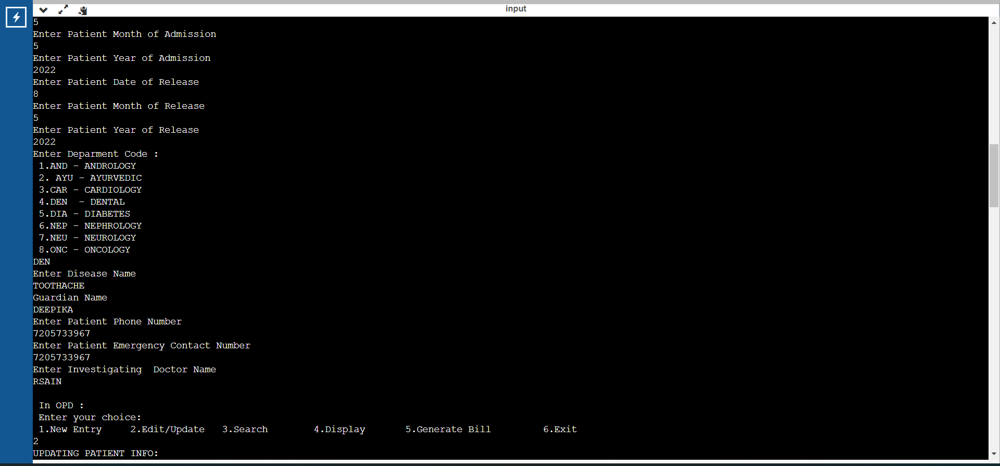

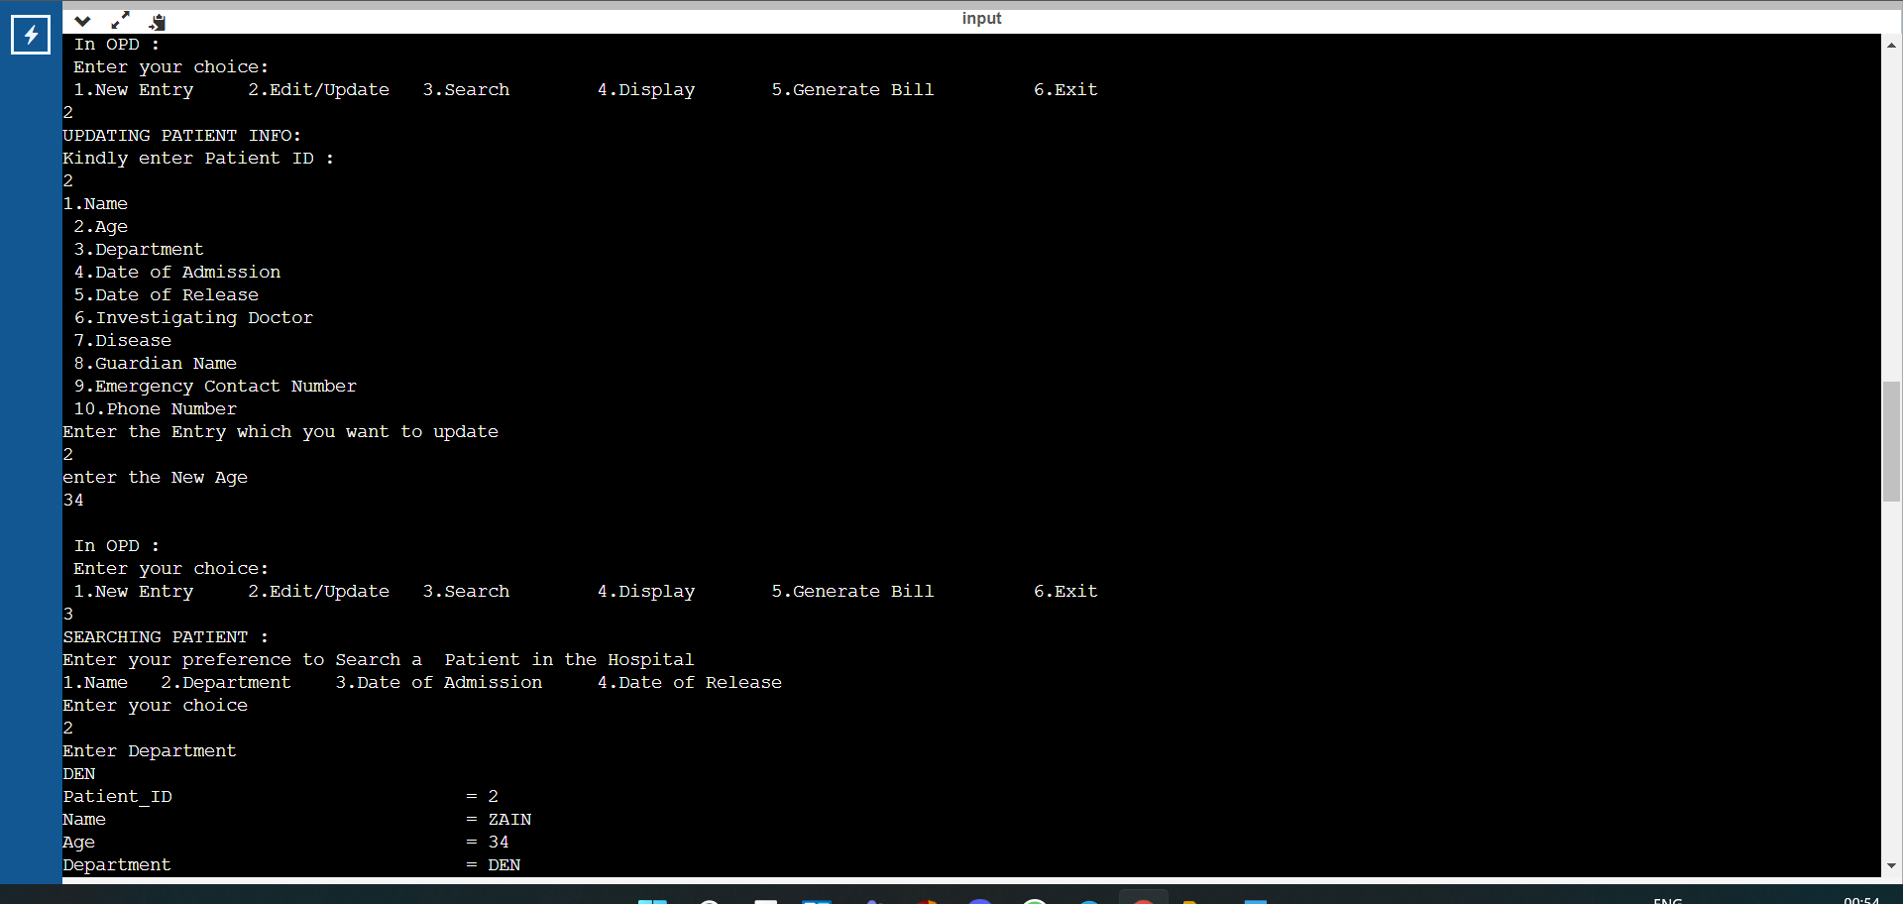

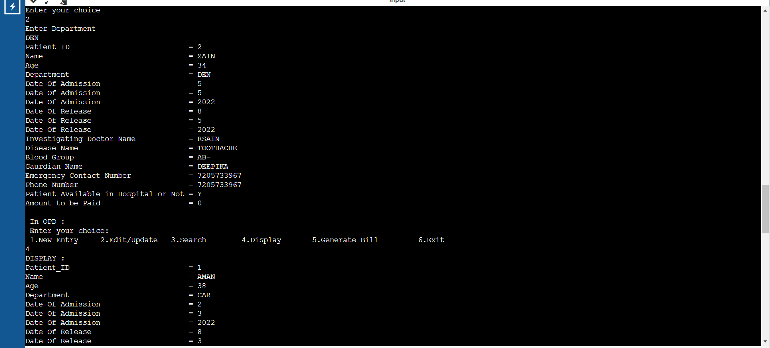

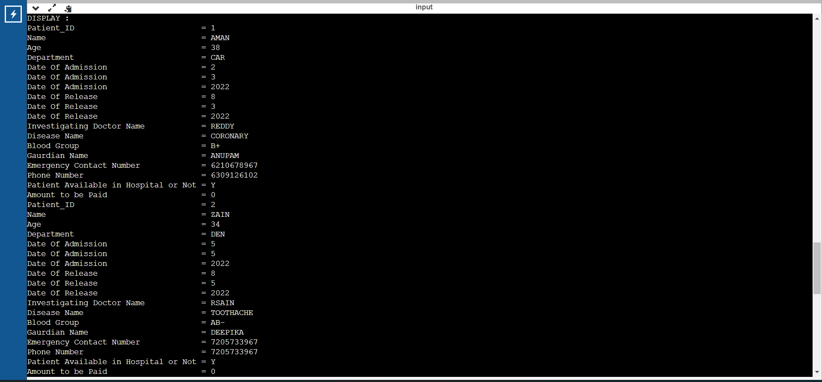

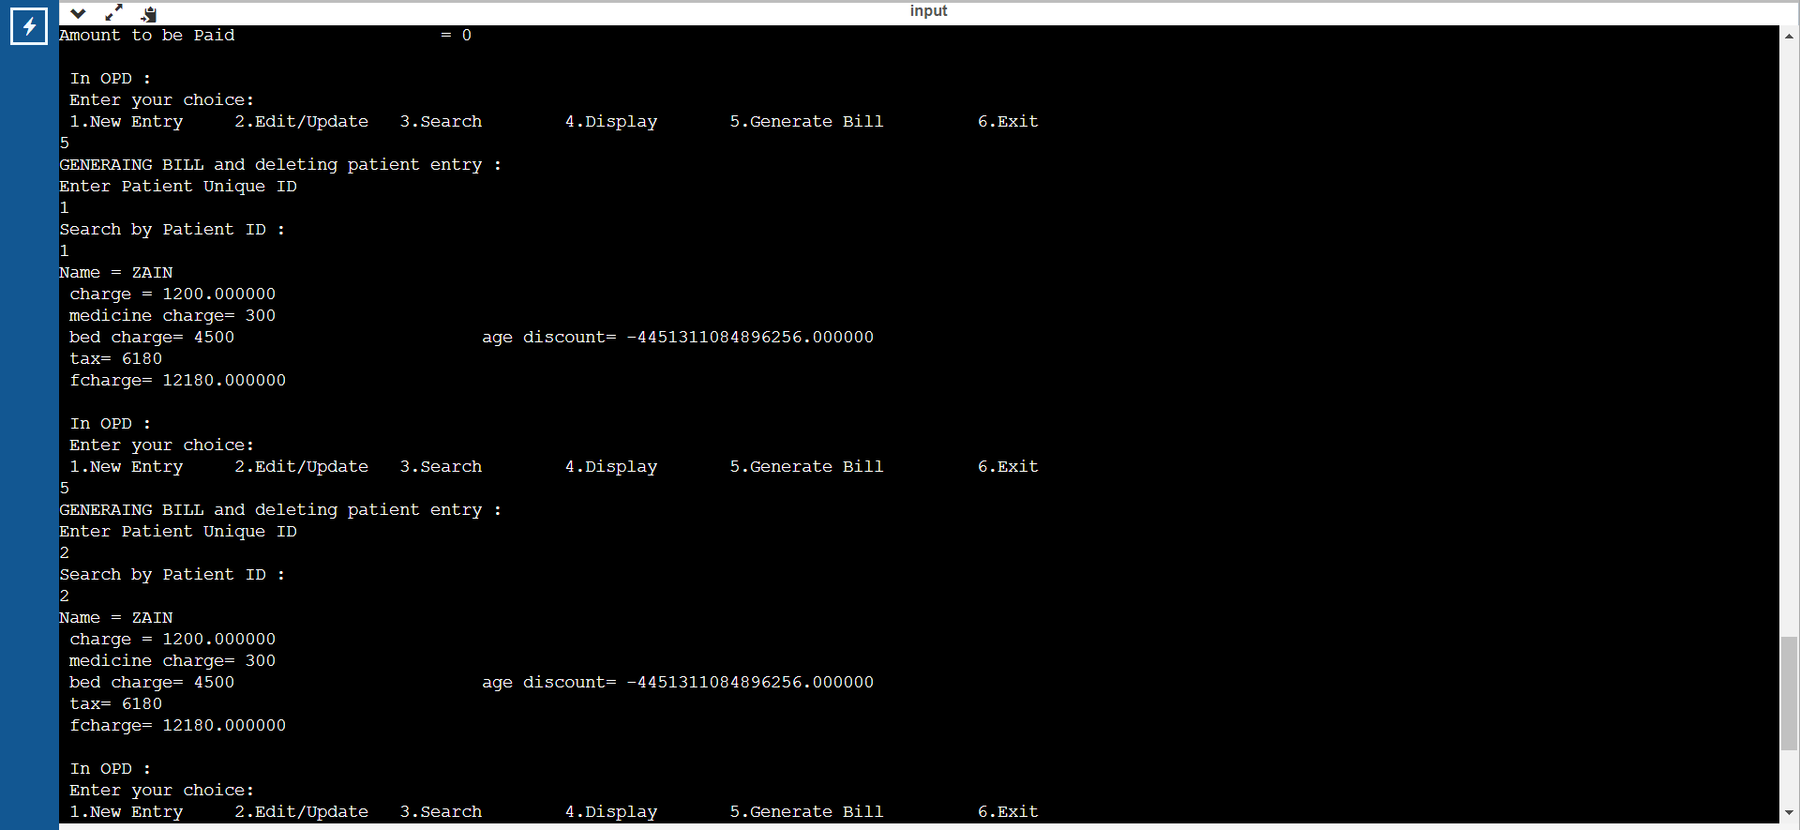

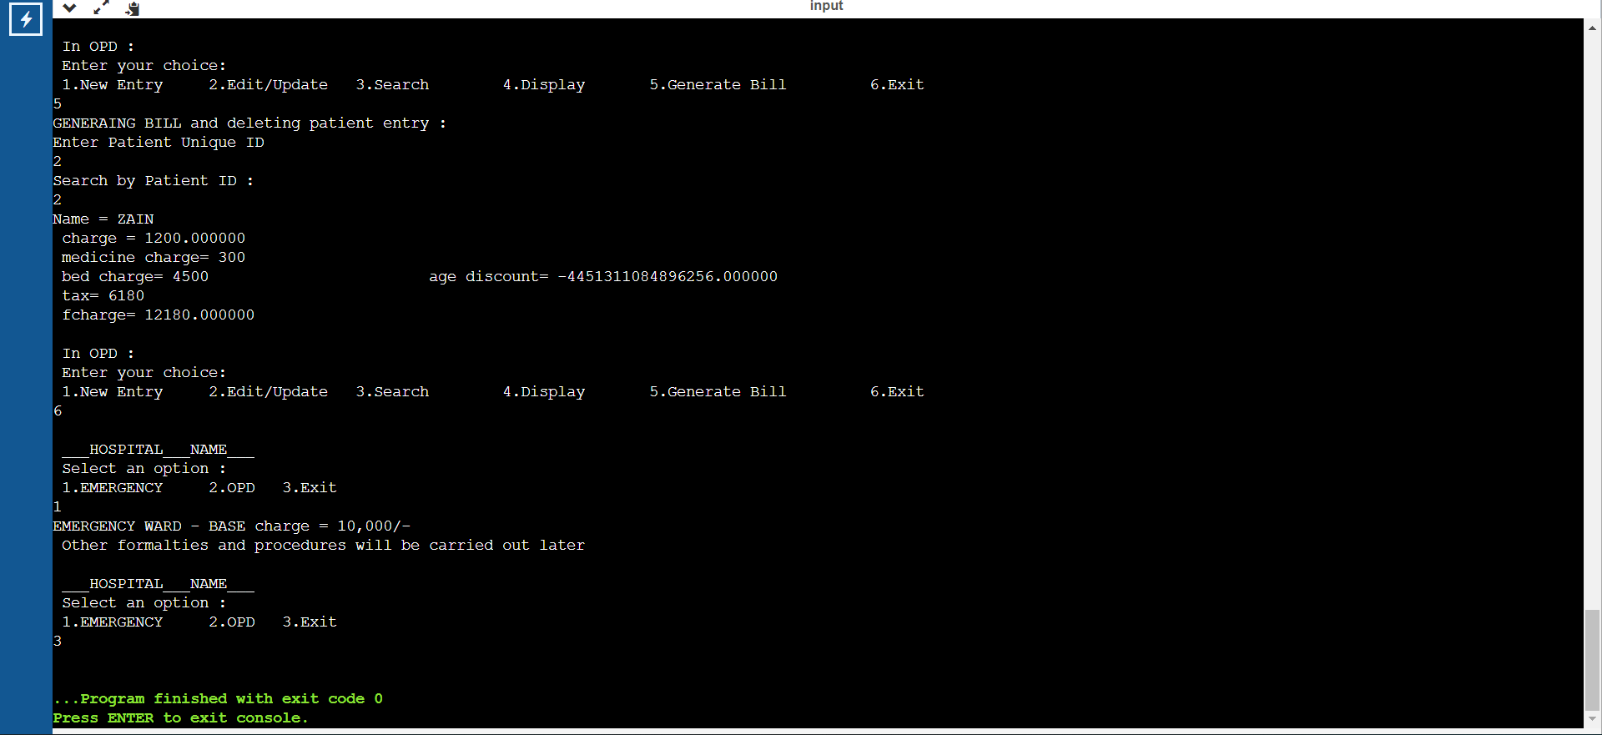

**CHAPTER-8**

**APPLICATIONS**

**8.1 Applications:**

With technology revolutionizing every industry, the health sector is not left behind. With several hospital software system developers emerging, it is imperative that any specialist get the right software.

Note that when it comes to handling patients is your health facility, certain services can be simplified with the right software.

**CHAPTER-9**

**CONCLUSION AND FUTURE WORK**

**9.1 Conclusion and Future Work:**

**9.1.1 CONCLUSION**

The code we built is a basic level code which will help the hospital management system in providing a user friendly and interactive interface for dealing with all the paper work and necessary hospital related query.

**9.1.2 FUTURE WORK**

Change is inevitable so are we humans, Change is Constant. We all grow, develop, and prosper

So will our code and the mini project we built. In order to improve our existing project, we can further add the cash free treatment covered under several Health Insurance Policies and further add the insurance segment also in our project.

**CHAPTER-10**

**REFERENCES**

**10.1 References:**

**10.1.1 geeksforgeeks.org**

**10.1.2 stackoverflow.com**

**10.1.3** [**www.tutorialspoint.com**](http://www.tutorialspoint.com)

**10.1.4 https://aticleworld.com/hospital-management-system-project-in-c/**